Chrome Radio FIX!!
If you’re using the Big G’s Chrome as your default browser and the play button does not want to latch … do the following, please!
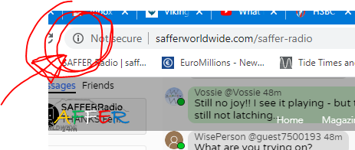
Click on the ℹ icon in the search bar – this opens up the screen below –
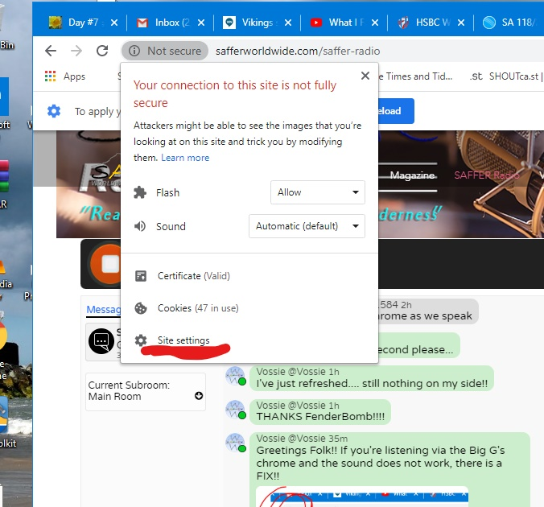
go to the site settings and select – this will open the settings screen -
Select ALLOW for Flash
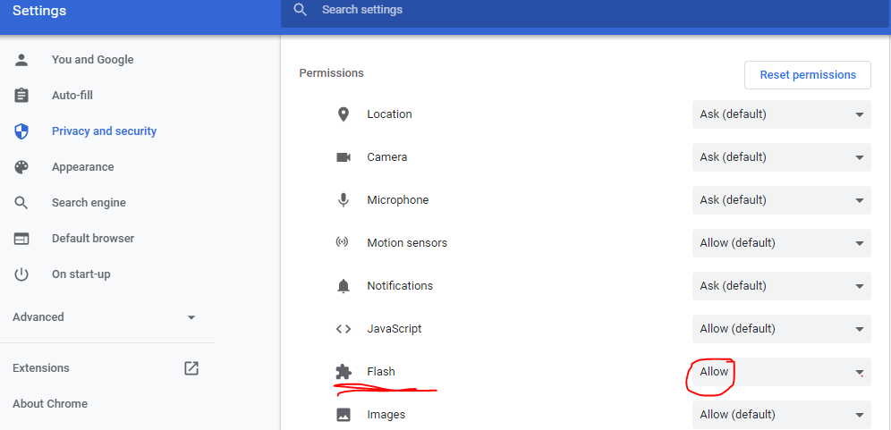
Scroll all the way down… select ALLOW to enable the “Insecure content”
Last but not least… reload the page… hit the PLAY button and listen away!!!
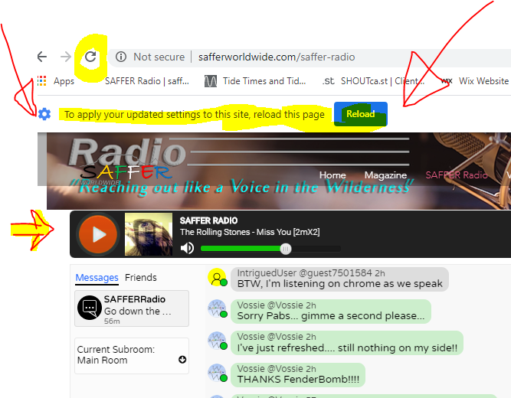
THANKS for your support!

